Patient Health Questionnaire (Page 1):
Patient Name:_______________________________ Date:_____/_____/20_____
- Please describe your symptoms:_______________________________________________________________________________________________________________________________________________________________________________________________
When did your symptoms start?_________________________________________________________________________
How did your symptoms begin?_________________________________________________________________________
____________________________________________________________________________________________________
- How often do you experience your symptoms? On the image below, mark where you have pain & other symptoms:
Constantly (76-100% of the day)
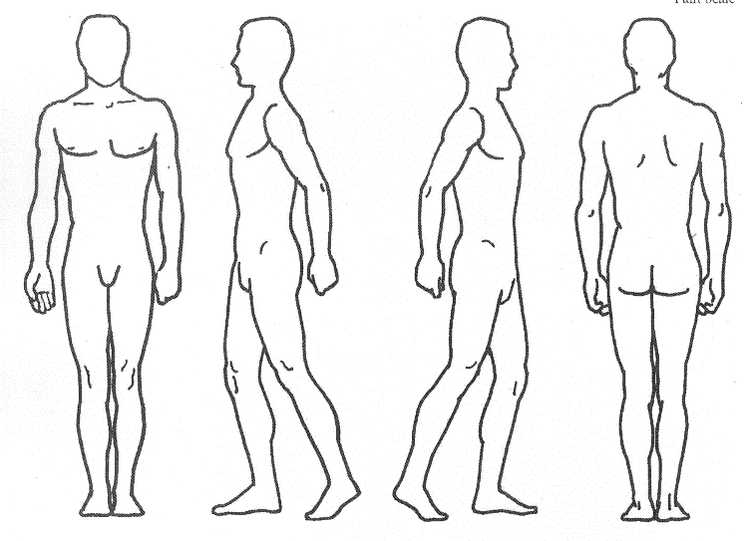
Frequently (51-75% of the day)
Occasionally (26-50% of the day)
Intermittently (0-25% of the day)

- What describes the nature of your symptoms?
Sharp Shooting
Dull Burning
Numb Tingling

- How are your symptoms changing?
Getting Better
Not Changing
Getting Worse

- On a pain scale of 1-10, 1= no pain 10= unbearable pain,
what number represents the average intensity of your
pain over the last 4 weeks?________________

- Over the last 4 weeks, how much has the pain interfered with your normal work (including work outside the home and housework)?
- Not at all B. A little bit C. Quite a bit D. Extremely
Over the last 4 weeks, how much has the pain interfered with your social activities?
None of the time A small amount of the time Some of the time Most of the time All of the time

- In general would you say your overall health is
Excellent Very Good Good Fair Poor

- Who have you seen for your symptoms?
No One Medical Doctor Chiropractor Physical Therapist Other:____________________________

What treatment did you receive and when?________________________________Date:____/_____/20_____

What Tests have you had for your symptoms and when were they performed?

______/_____/20____MRI ______/_____/20____Xrays

______/_____/20____Other ______/_____/20____CT Scan
Patient Initial Here:_______________

Patient Health Questionnaire (Page 2):

Patient Name:_______________________________ Date:_____/_____/20_____
- Have you had similar symptoms in the past? Yes No

If you have received treatment for similar symptoms in the past, who did you see?
This Office Medical Doctor Chiropractor Physical Therapist Other:________________

- What is your occupation?
______________________________________________________________________________________________

If you are not retired, a homemaker, or a student, what is your current work status?
Full Time Part Time Employed Unemployed Off Work Other:____________

- What activities does your problem prevent you from doing?
Walking Reaching Bending Dressing Grooming Hygiene Housekeeping Driving Home Making Other:________________________

- What Medical equipment do you have at home?
Walker Wheel Chair Hospital Bed Commode Shower Equipment

- What is your current living situation?
Live Alone Live With a Caretaker Live with a Family Member

- Please list all medications and herbal supplements you are taking now

__________________________________________________________________________________________________

- Please List any allergies:

__________________________________________________________________________________________________

- Do you have any of the following medical conditions? (Check all that apply)
Diabetes Mellitus High/Low Blood Pressure Incontinence Defibrillator Implant
Open Wounds History of Seizures Psychiatric History Radiation or Chemotherapy
Osteoporosis Cancer or history of cancer Urinary Tract Infection Heart Disease/Hardening Arteries
Sensory Deficits Immune System Compromise Respiratory Disease Arthritis
Lymphedema/Lymphedema Treatments Pacemaker Neurological Disorder
Other:________________________________________
Past Surgeries/Approximate Year:
________________________________________________________________________________________________
- Answer the following statements by checking yes or no. Have you had?
Yes No
An unexplained weight loss of greater than 10 lbs. in the past month?
Numbness in both hands and/or both feet at the same time?
Any changes in your bowel or bladder habits?
Any numbness in your backside, in the area where you would sit on a bicycle seat?
In coordination or weakness with walking?
Any loss of balance or recent falls?

Patient Signature __________________________________ Date:____/_____/20____

